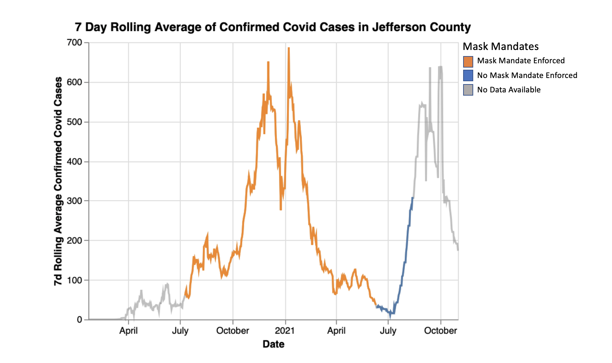

The above visualization shows the 7day rolling average COVID case counts for Jefferson County, Kentucky from Feb 2020 - Oct 2021. The case counts are color coded by whether or not, on that day a mask mandate was in place.

What’s really interesting is that around 15 days after the mask mandate was removed, there was a huge spike in cases. This 15 day lag can be attributed to both - the fact that it takes a few days for a case to be documented after exposure as well as the way we are calculating the 7d moving average.

This can further be seen if we look at the increase in cases (7d average) from the previous day- you notice that when the “no mask mandate” was passed, the mean increases significantly above the zero line.

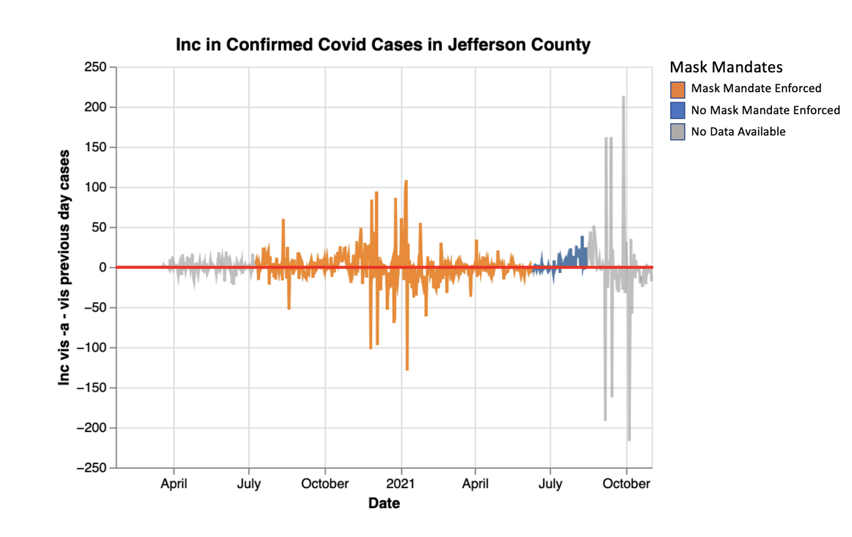

Issues/Next Steps:

* While, I did smooth the counts by taking 7 day averages, there are still a few days where there are sudden increases followed by sudden decreases - this could be due to public holidays when cases weren’t logged
* We have mask data till August, in September, the rate of increase in cases does show a decreasing trend. It would be interesting to see if this is due to a new updated mask mandate/ something else.